Janice Ainembabazi

Southern New Hampshire University

CS-340-18683-M01 Client/Server Development

Prof. Jeff Sanford

November 10th 2024

Loading Data using mongoimport by accessing the dataset

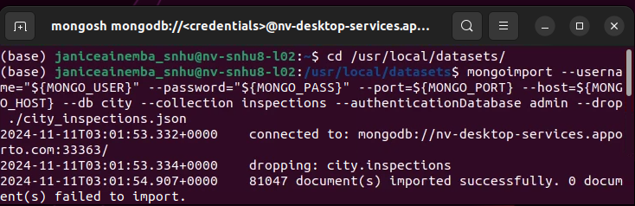

Verifying data load and performing the basic queries

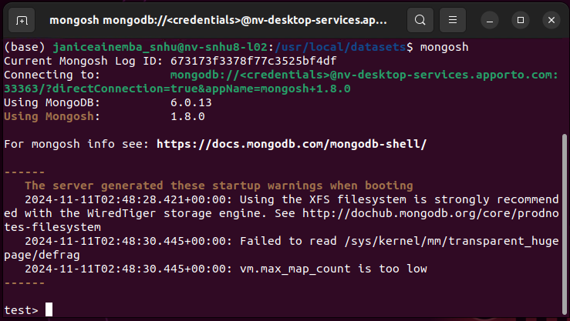

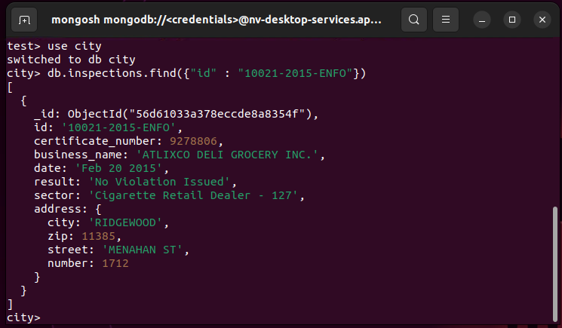

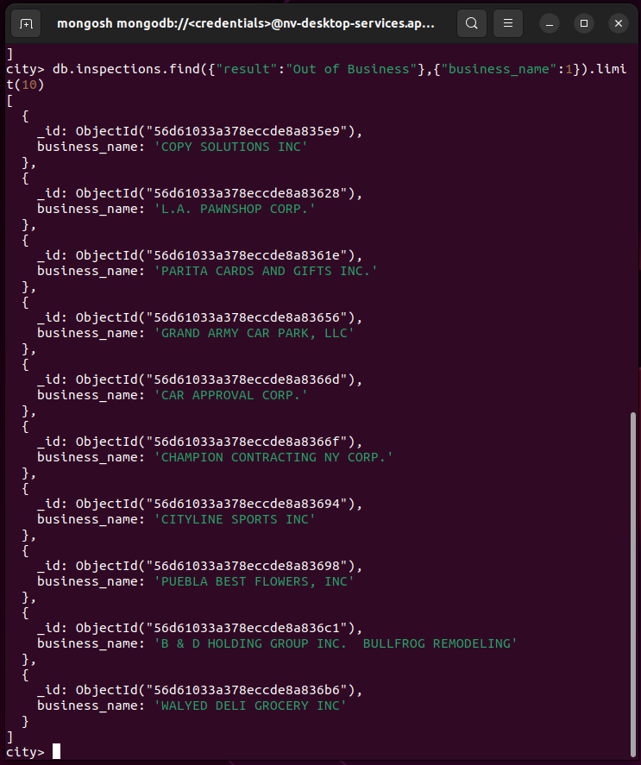

Inserting a new document

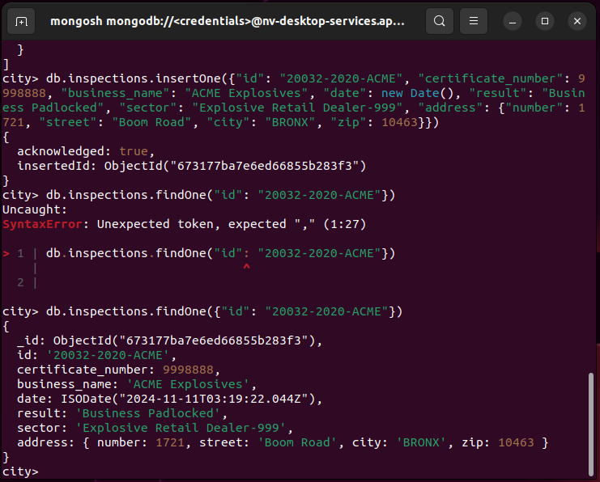

Performing the additional MongoDB Queries

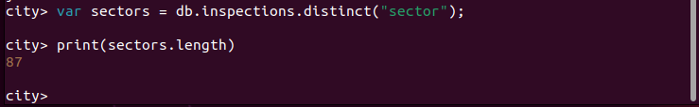

On the list, there are 87 distinct entries.

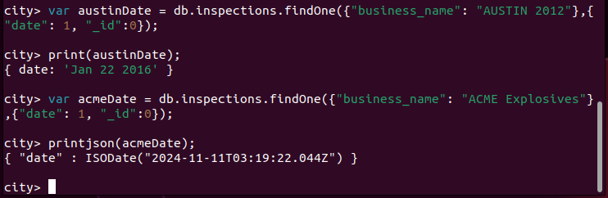

The number of businesses that have a violation is 0. So no businesses have a violation issued.

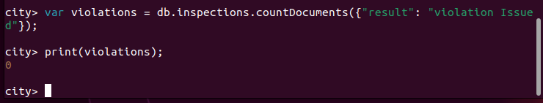

Updating Document with ID “20032-2020-ACME”

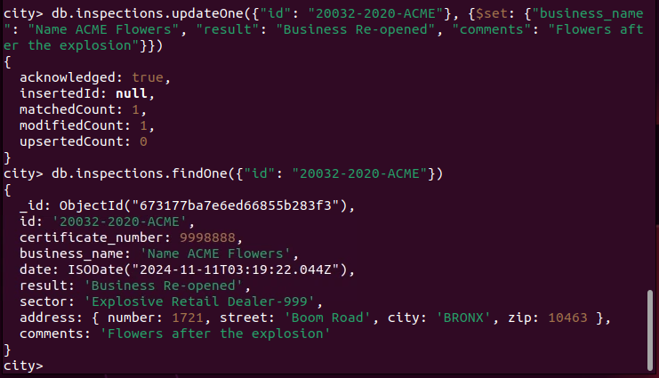

Updating all documents

